Accessing the Pulse / Edstrom (Avidity) System

If you have been assigned access to the Pulse system for freezer and other equipment monitoring, you can access the system to review and silence alerts from inside and outside of the VBRI network:

* **INSIDE the FBRI Network**: If you are in the FBRI or connected to the VPN, you can access the Pulse Console via: [http://pulse.vtc.vt.edu](http://pulse.vtc.vt.edu/).  Use your assigned Pulse credentials to login.  NOTE: It can take a minute or two for the Pulse login screen to load.
* **OUTSIDE the FBRI Network**: If you are not at the FBRI and need access to the Pulse Console, visit [https://pulse.vtc.vt.edu](https://pulse.vtc.vt.edu/).  Use your **FBRI credentials** (those used to log into our resources such as email) on the very first screen, and then use your assigned Pulse credentials when the Pulse Console login appears.  NOTE: It can take a minute or two for the Pulse login screen to load.

If you need credentials to log into Pulse, have your Lab Manager or PI "Start a Conversation" on this site to submit a request for access.  Have them include the specific equipment you will need access to.

Once in the Pulse / Edstrom (Avidity) System, click **Login** in the upper right corner

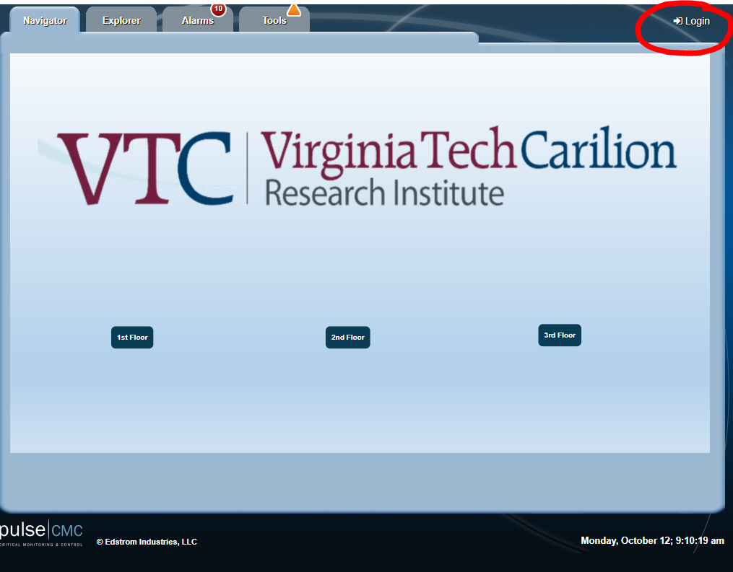

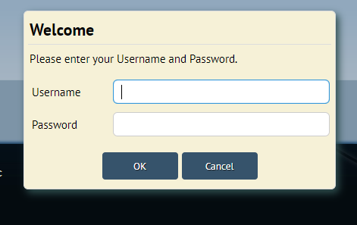

*Logging in will enable you to acknowledge and silence alarms.*

To view your freezer, click on the **Explorer** tab and navigate to your freezer

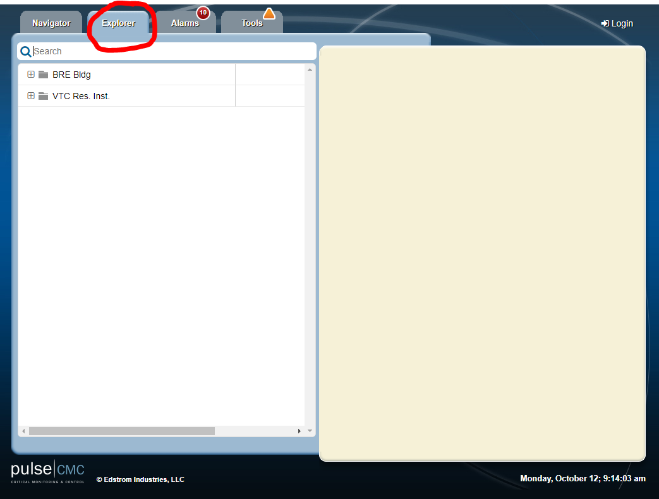

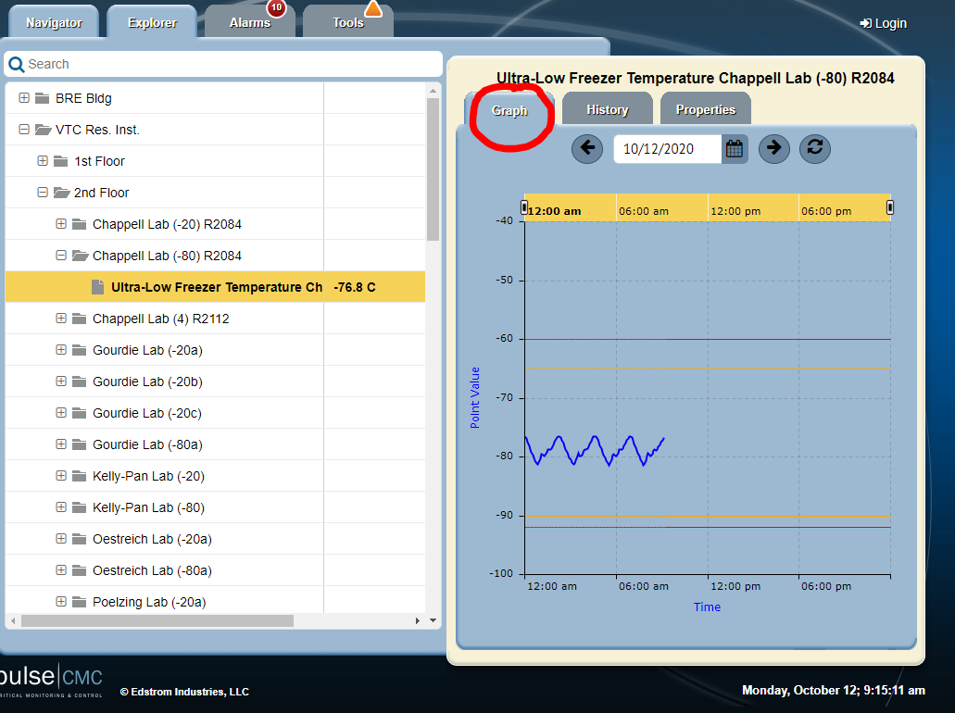

Click **Graph** tab to look at the temperature trend.

To silence an alarm, click on the **Alarms** tab and scroll until you find your alarm.

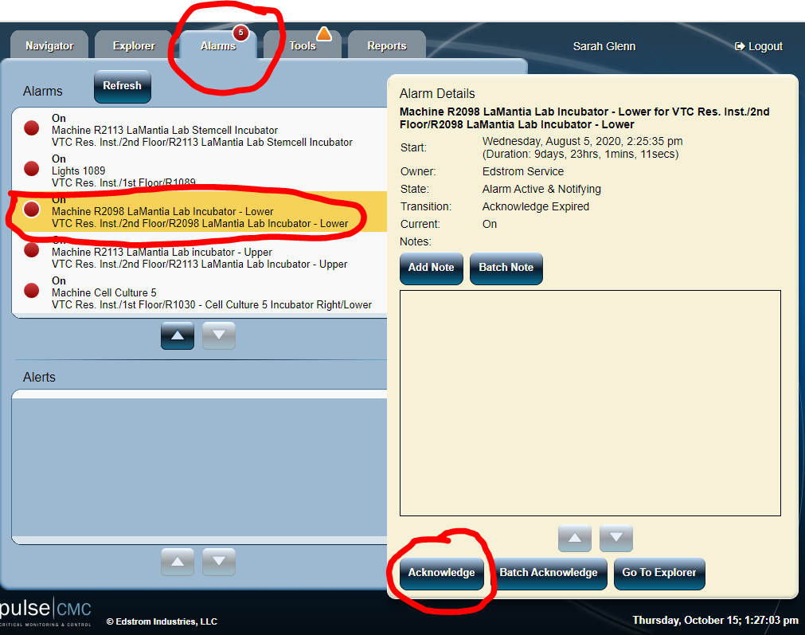

*You must be logged into the Pulse system in order to acknowledge and silence alarms.*

When you acknowledge alarm, note the duration of time for the acknowledgement.

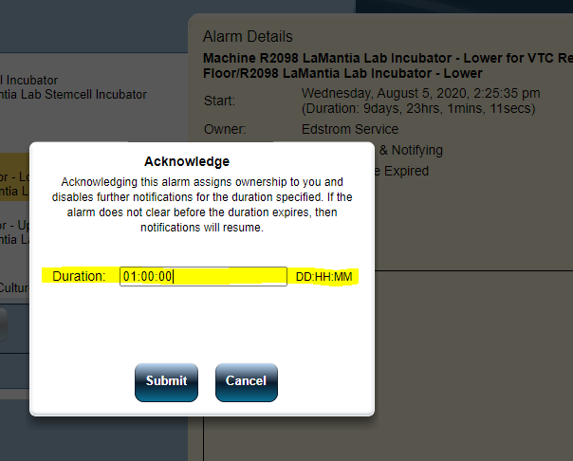

The default is 1 day. This may be too long depending on the issue.

If an alarm has “cleared” (i.e. the problem is over; temp is back in range for freezers), acknowledging an alarm will silence that alarm for good. If the equipment experiences another issue, the system will send out a new alarm.