Entering an ISR (Interdepartmental Service Request)

ISRs are located in HokieMart – Log-in to HokieMart

Before keying the ISR know the fund number and the account code – account codes can be found here [Account Code List](http://www.co.vt.edu/accounting_operations/Account_Code_Listing/accts.html)

Click on **Interdepartmental Service Request** box under University Forms section

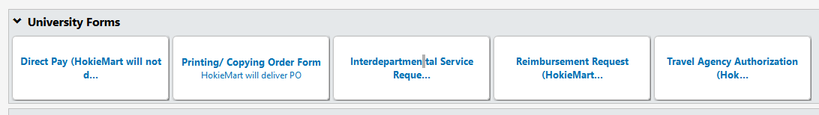

The ISR box will pop up

* Supplier Info Section
  + **Supplier** > for example VT Parking Services > Click on the drop down arrow
  + **Fulfillment Address** will automatically populate with the address depending on the department selected
* General Info Section
  + **Catalog No.** > Should always be ISR when entering ISRs
  + **Product Description** > provide a description which will tell the supplier exactly what you need
    - **Example for VT Parking Services:** 2016 – 2017 Temporary Parking Passes for VTCRI
  + **Quantity** > the amount needed (1, 2, 3, etc.)
  + **Packaging** > If each doesn’t suit then click the drop down arrow and chose from there
  + **Estimated Price** > The price for *each* item (by weight, day, dozen, etc.)
* External Info Section:
  + **Service Required by** > Click on the calendar or key in the date (varies between purchases) if unsure key the next day’s day
  + **Department** > Key the department name (Currently VTCRI)
  + **Building / Room** > Name of building and office number (ex. Bldg 2 Rm R1004)
  + **Contact Name** > Your name
  + **Contact Phone** > Your office phone number
  + External Notes > Not required; if there is more information, besides the product description, you think the supplier needs; key the information here. For example, a quote/proposal number or shipping instructions.
  + External Attachments > Not required; if you have a quote/proposal attach here
  + **Total** > is blank at this – why? I don’t know.

Completed Example of ISR General Information – Using VT Parking Services

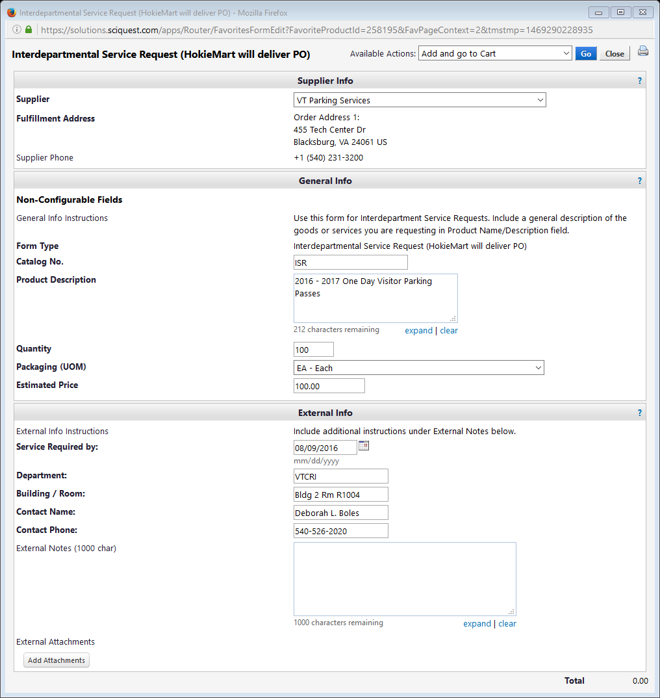

Once all information has been keyed, at top right corner **Available Actions** *Add and go to Cart* **click** 

* There are other choices at the drop down arrow if you need

Once you click Go HokieMart uploads the information to your 

**Now to key information for the Checkout Process**

Shopping Cart – Sender and Supplier Info

* **Cart Name:** Optional *I recommend naming the cart if you key numerous requisitions; easier to search through requisitions*
* **Priority:** Leave as *Normal* unless absolutely necessary to choose *Urgent* (under drop down arrow)
* Next Fiscal Year: Leave blank unless instructed to use – use is a rarity when keying ISRs
* **Notify AP-Prepayment:** Only if department requests deposit/payment before service – rarity in ISRs
* Prepared for: If you’ve been instructed to key ISR and this person should be contacted then click  otherwise leave your name
* **Internal Note:** Click and give reason for the purchase – what it is and how it relates to general department use or how it relates to the project.
* Send to Supplier?:

*in other requisition forms this can be changed*

* + Select from profile values: ISR: Default is HokieMart will deliver
  + Select from all values: ISR: Default is HokieMart will deliver
* Note to all Suppliers: If there is information the supplier needs to know make a note here
* **Supplier / Line Item Details:** Information keyed in ISR form – unless an error no changes necessary
* **Click**  **if you do not all information will not carry over to checkout**

Completed Example of ISR Shopping Cart – Sender and Supplier Info

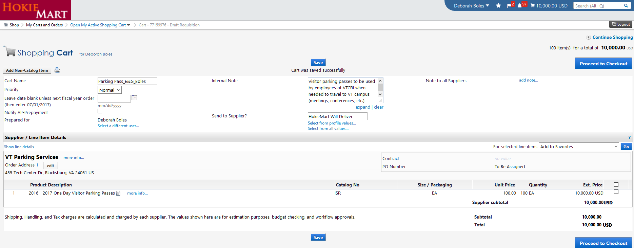

All information keyed, **reviewed,** and **saved** top right hand corner (or bottom right hand corner) Click



Keying Funding Info

* To key funding information on the middle right side of screen click  and this opens the yellow boxes to key your values. This info tells HokieMart what department to charge (Fund) and what the department is purchasing (Account).

Accounting Codes Pop up Box:

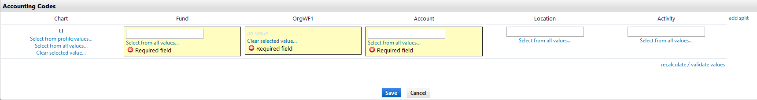

The fields for **Fund** and **Account** are open for value keying

* Chart: Default value
* **Fund:** Number to charge purchase - You may *Select from all values* but as said in the beginning you should have this number before beginning the ISR (ex. VTCRI E&G fund number or Project fund number)
* OrgWF1: Nothing – Will validate value in 2 steps
* **Account:** Number to identify purchase - You may *Select from all values* but as said in the beginning you should have this number before beginning the ISR (ex. Is product a service, lab supply, or equipment) Choose account code from the Account Code List.
* **Click:** validate the values entered and notice OrgWF1 has automatically filled in
  + Recalculate works with the *add split*option which was not used
* If you still see  then either *fund*  or *account* codes are incorrect; possibly both. Correct values before you can continue
* **Click:** 

Completed Example of ISR Funding

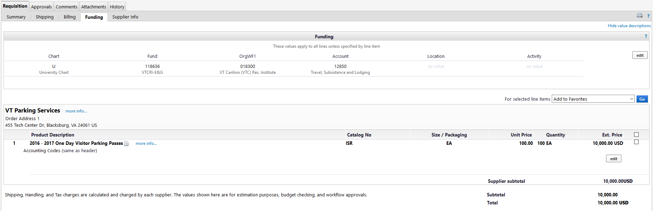

Internal Attachments:

Upper Left Corner Click:



The Internal Note keyed in the Shopping Cart – Sender and Supplier Info part of the requisition. If you want to revise your note click .

Click  If there are documents which should be attached to the requisition. Add Attachments pop up box click *Select files…* chose the document then click *Save Changes*. The attachment is now located in the Internal Notes and Attachment box.

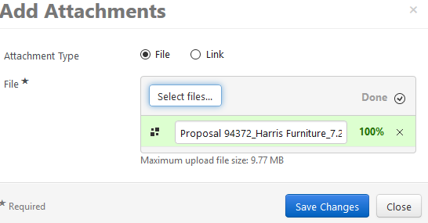

Completed Example of ISR Internal Notes and Attachments

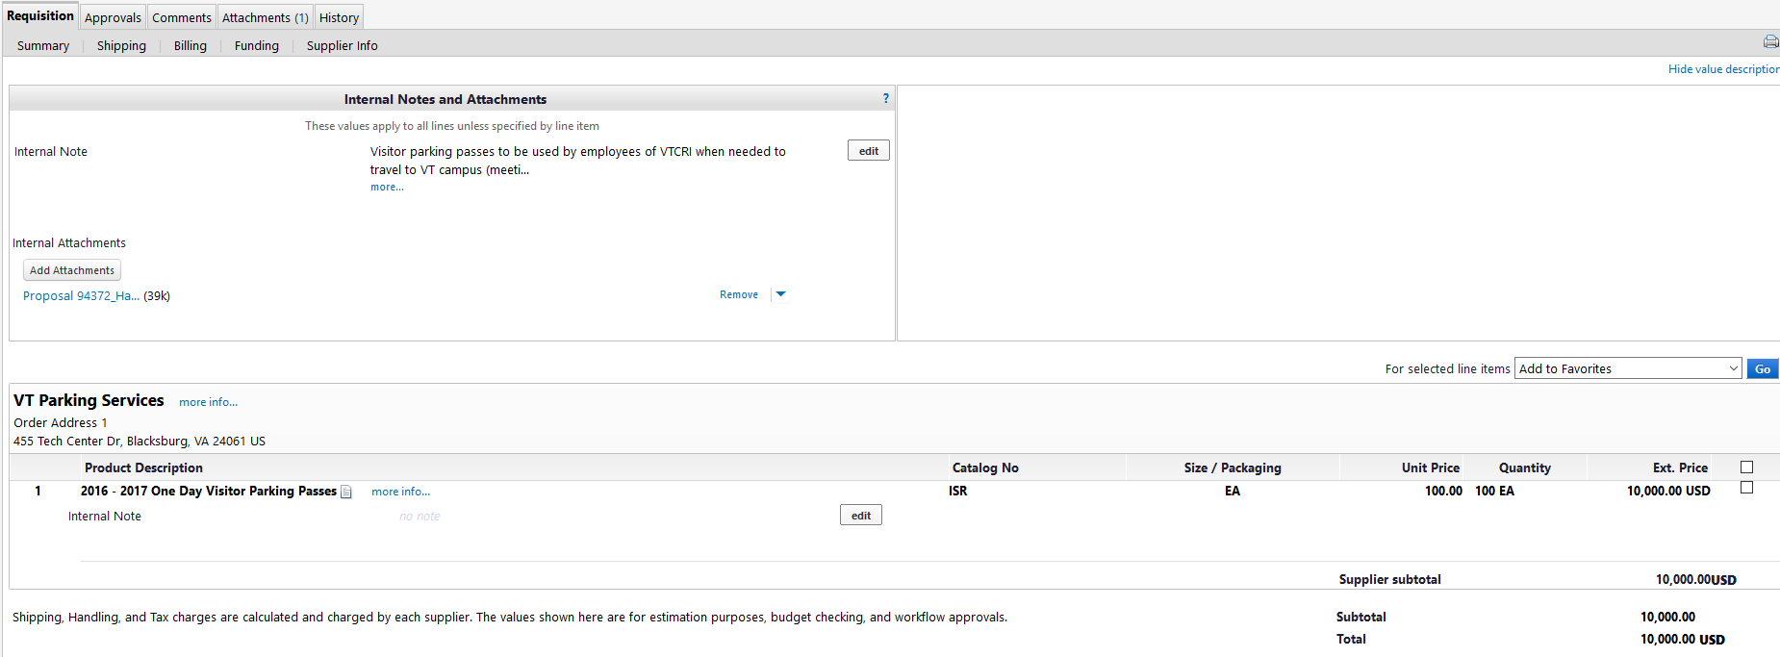

Click to add information or document(s) which need shared with the supplier

Click  Last chance to review the ISR for errors

When read click 

The ISR will go through budget authorization, a 2 level approval process, AP notification before receiving the purchase order number.

The ISR (or requisition) is completed and the requisition number given is the identifier and place holder for the original information keyed into HokieMart.

Completed Example of ISR

